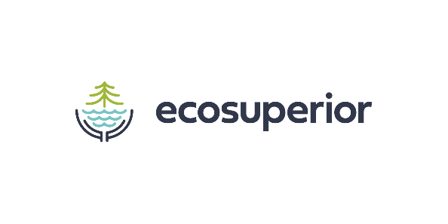
Drainage Rebate Program Participating Plumbers List
As of May 10, 2022

Company | Phone Number
A Villeneuve Mechanical | 622-8835
B. Gibson Mechanical | 631-9060
Clow Darling | 623-7485
Thermal Mechanical Systems | 345-5200
Twin City Plumbing and Heating | 475-5055

